

International University - Net-Centric Programming



TERM PROJECT

Instructor: Le Thanh Son

Project Task: Music Crawler and Music Player

Trương Công Trung

ITITIU19059

Contents

1 Introduction 3

1.1 Background 3

1.2 Objectives 3

2 Music Crawler 3

2.1 Collect list of songs 3

2.1.1 Request 6

2.1.2 Request URL 7

2.1.3 SIG 8

2.1.4 Cookie 11

2.1.5 List of songs 11

2.2 Getting songs’ information 12

2.3 Getting songs’ lyric 14

2.4 Getting songs’ audio 16

2.5 Main function 17

3 Music Player 18

3.1 webserver.py 19

3.2 music.html 20

3.3 song_info.html 21

3.4 song.html 22

4 Usage 23

5 Conclusion 23

6 Referrer 23

# Introduction

## Background

In order to gain practical experience in the network programming course, I pick up the term project of music crapper, which plays on detecting and understanding the API from an online music site.

## Objectives

In this project, I will dig on zingmp3.vn, understand how data work in there and try to collect as much as valuable information from them. Then build my own system to deploy the simplest website which shows all local data.

# Music Crawler

## Collect list of songs

The first step is to determine what data to get and where it can be collected.

I choose a target that is the most unstable page but also the most valuable page, which will always have new songs and have a real-time update.

<https://zingmp3.vn/moi-phat-hanh>

Open the “Network” tab in “Develop tools” of the browser, I could observe the activities of the website, and find out the way that data was requested.

Following the “Request URL”, the json data shows up and our job is just to collect “encodedID”, which is the representative of song.

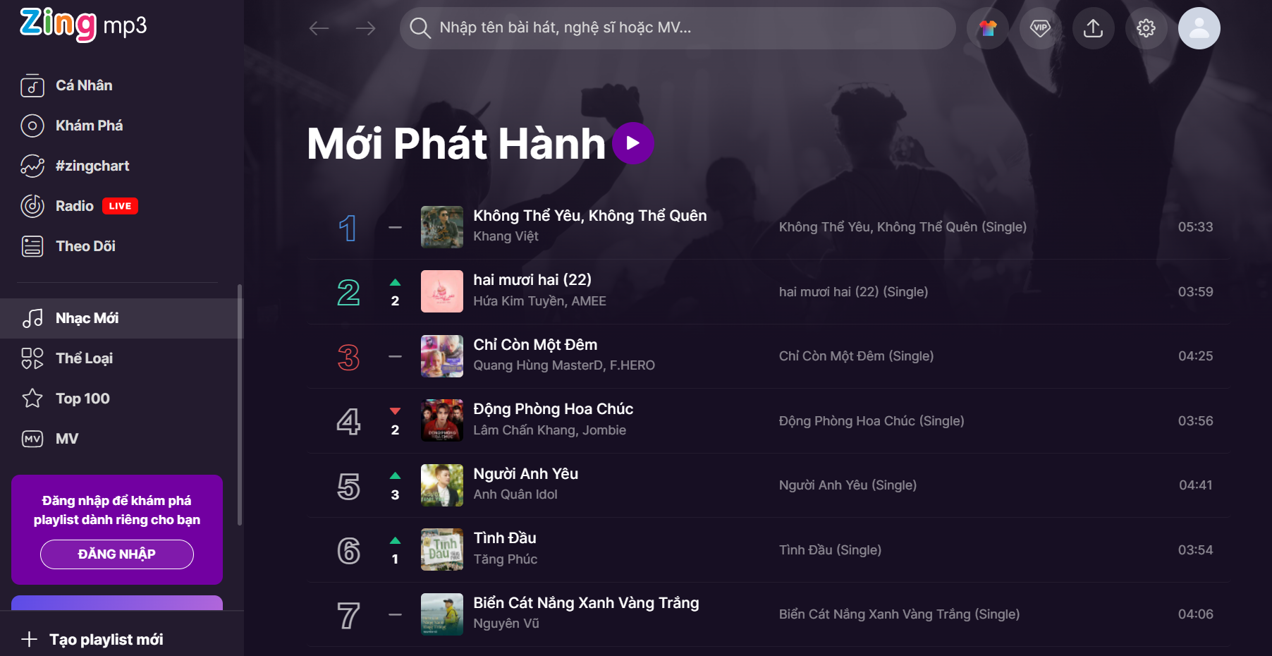

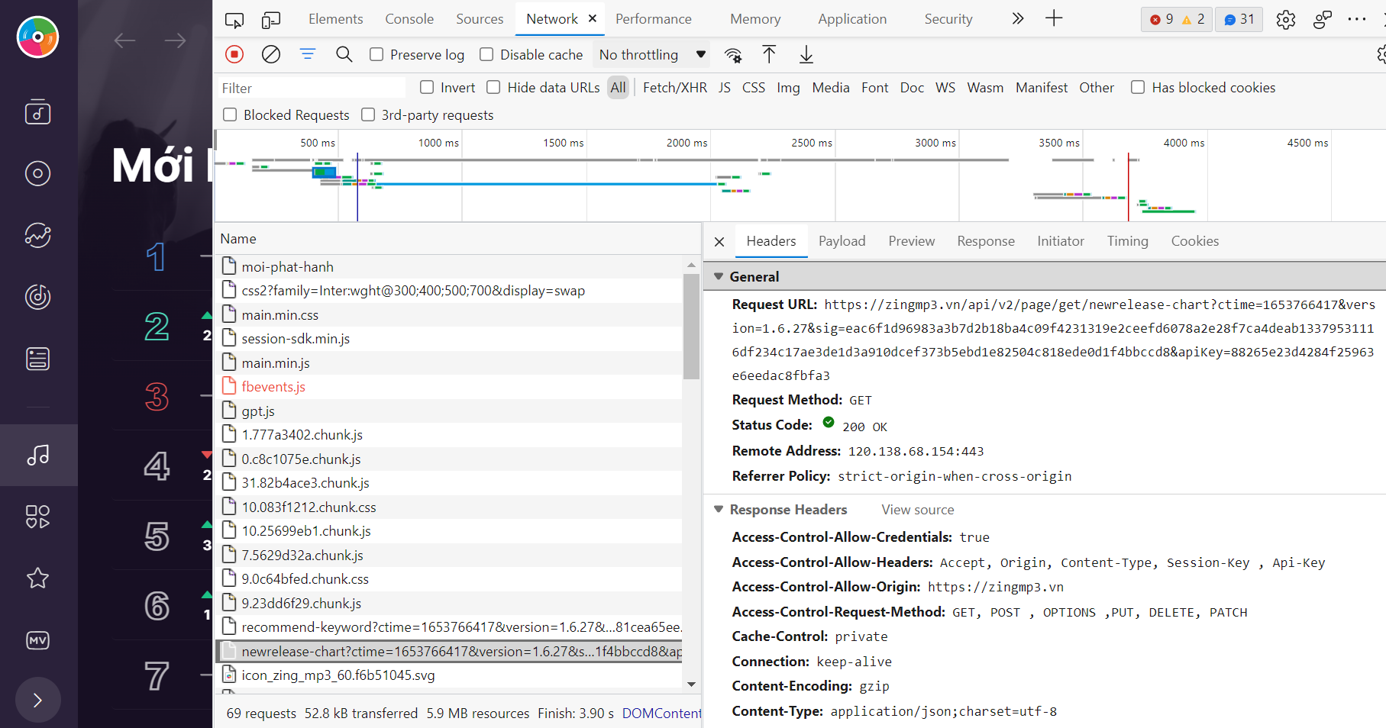

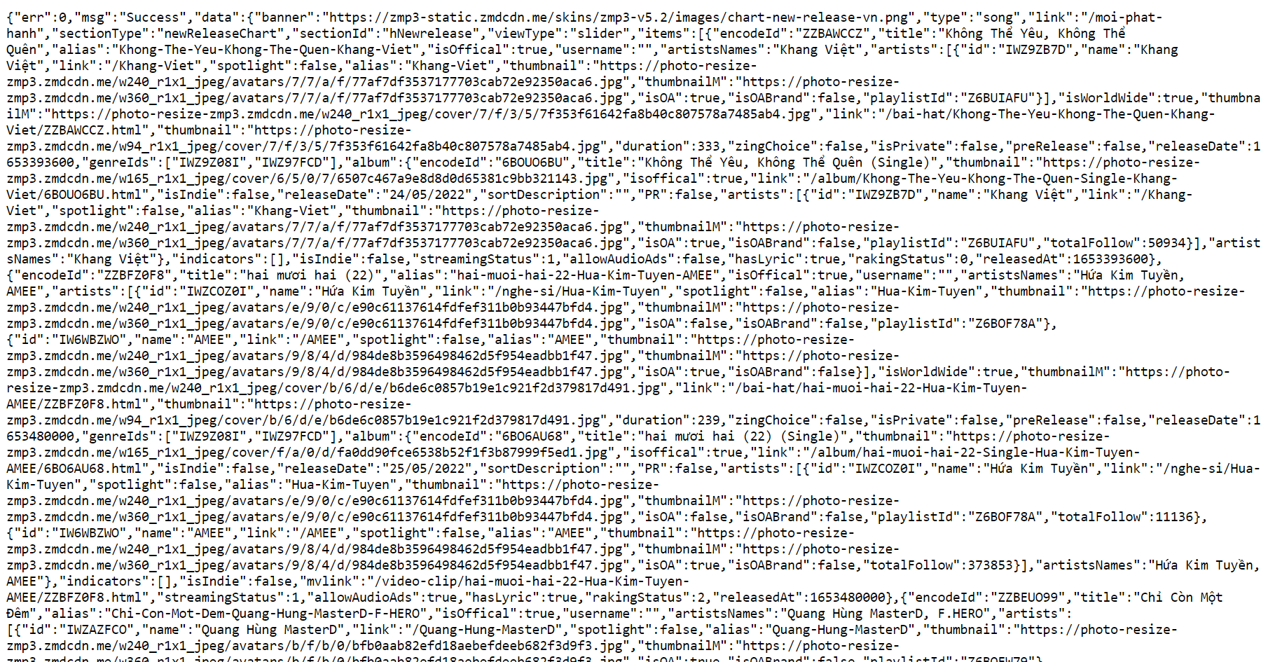

### Request

The next step is to build a valid request in order to legally get data from the website. I use <https://reqbin.com/> to make a test base-on “Request URL” and “Request Headers”.

**Request URL:** https://zingmp3.vn/api/v2/page/get/newrelease-chart?ctime=1653766417&version=1.6.27&sig=eac6f1d96983a3b7d2b18ba4c09f4231319e2ceefd6078a2e28f7ca4deab13379531116df234c17ae3de1d3a910dcef373b5ebd1e82504c818ede0d1f4bbccd8&apiKey=88265e23d4284f25963e6eedac8fbfa3

**Request Header:**

User-Agent: Mozilla/5.0 (X11; Linux x86_64; rv:91.0) Gecko/20100101 Firefox/91.0

Accept: text/html,application/xhtml+xml,application/xml;q=0.9,image/webp,*/*;q=0.8

Accept-Language: en-US,en;q=0.5

Accept-Encoding: gzip, deflate, br

Upgrade-Insecure-Requests: 1

Sec-Fetch-Dest: document

Sec-Fetch-Mode: navigate

Sec-Fetch-Site: none

Sec-Fetch-User: ?1

Connection: keep-alive

Cookie: zmp3_rqid=MHwyNy43Ni4xMTAdUngMjA5fG51WeBGx8MTY1MzmUsIC5NjE4MjU0Mg

Cache-Control: max-age=0

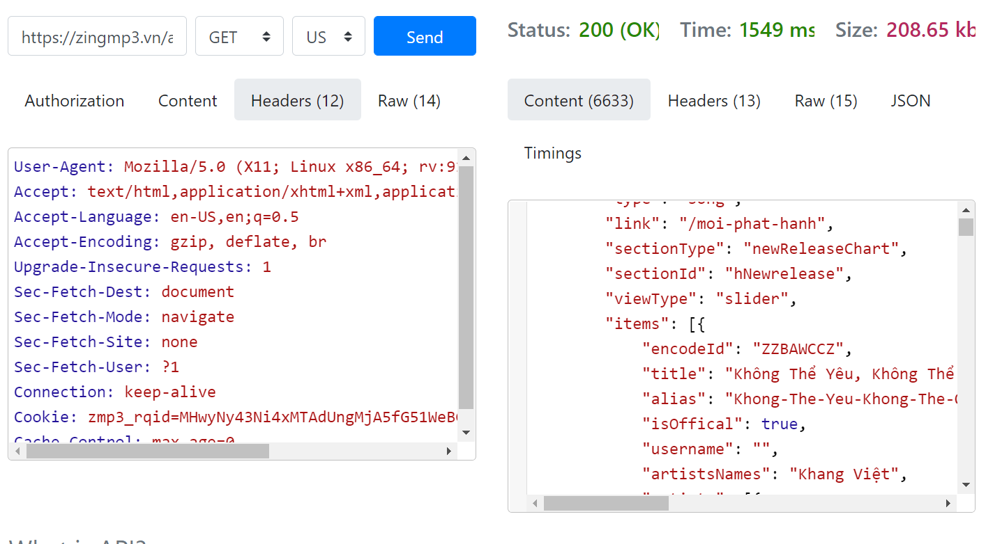

### Request URL

In “Request URL”, there are several arguments:

* Host: https://zingmp3.vn/
* API type: /api/v2/page/get/newrelease-chart
* Time: ?ctime=1653766417
* Version: &version=1.6.27
* Signature: &sig=eac6f1d96983a3b7d2b18ba4c09f4231319e2ceefd6078a2e28f7ca4deab13379531116df234c17ae3de1d3a910dcef373b5ebd1e82504c818ede0d1f4bbccd8
* API key: &apiKey=88265e23d4284f25963e6eedac8fbfa3

Host simply is the website url.

API type could be discovered like “top 100 of genre”, “lyric”, “song”, “stream”.

/api/v2/page/get/newrelease-chart

/api/v2/page/get/song

/api/v2/lyric/get/lyric

/api/v2/song/get/streaming

Time is to avoid an unknowledge crawl bot. Each time the user makes request, it will get current time and mix with other values in order to calculate valid “sig”. But it will be a big flaw when I discovered their encrypt algorithms, “ctime” could be a constant value and still be a valid request.

Version is a constant value.

### SIG

Request being handled by “main.min.js”

Searching for “apikey”, I could find “apiKey” argument and also point out and make a breakpoint for debugging, and discover their encrypt algorithms.

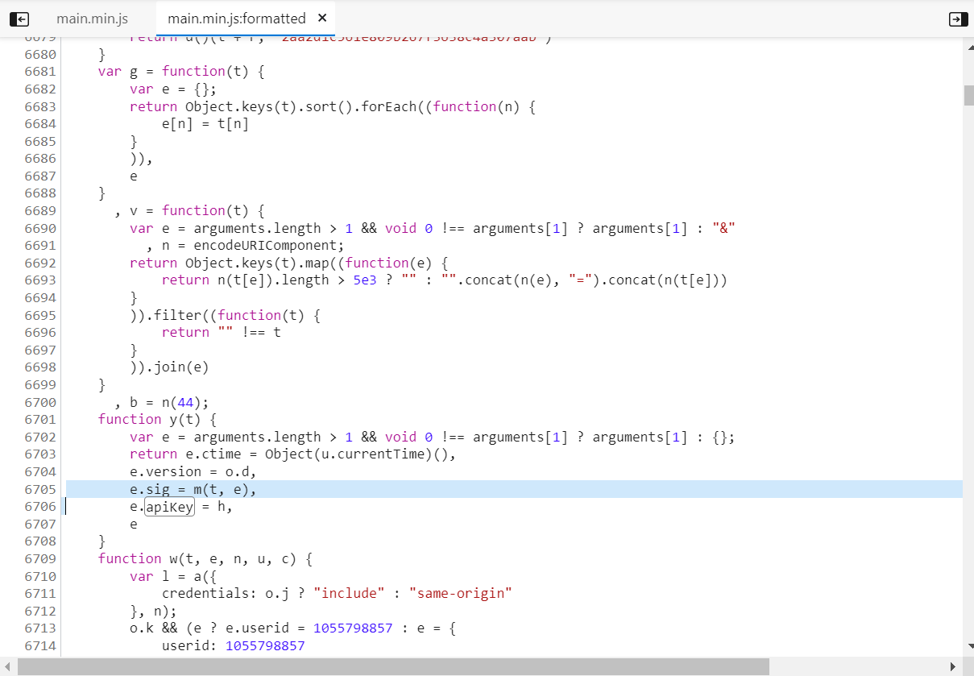

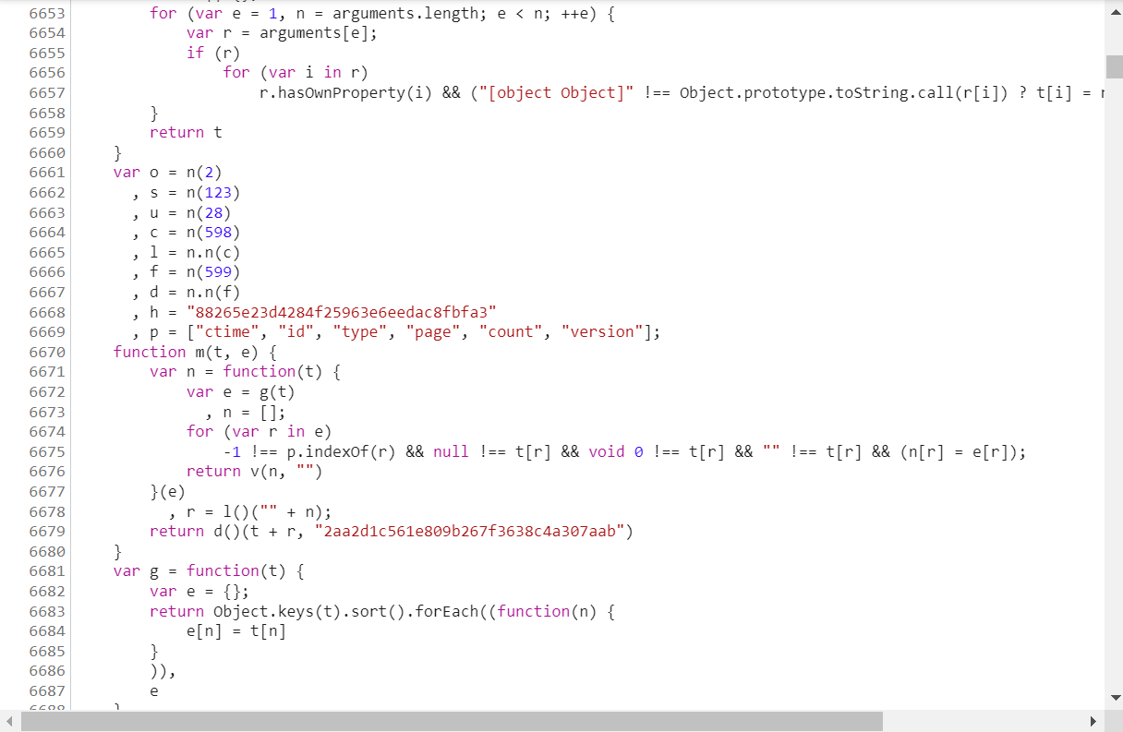

In summary, it will take arguments from request url, concat and calculate their SHA256. The result will concat with “apitype” string and hash by SHA1 with secret key SEC=”2aa2d1c561e809b267f3638c4a307aab”

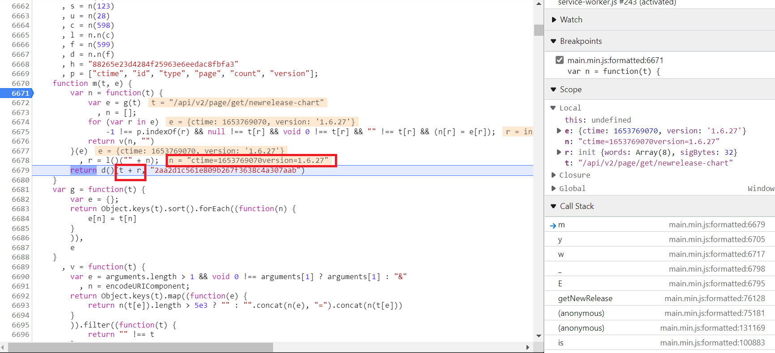

n = "ctime=1653769070version=1.6.27"

r = SHA256(n)

sig = SHA512(“/api/v2/page/get/newrelease-chart” + r, SEC)

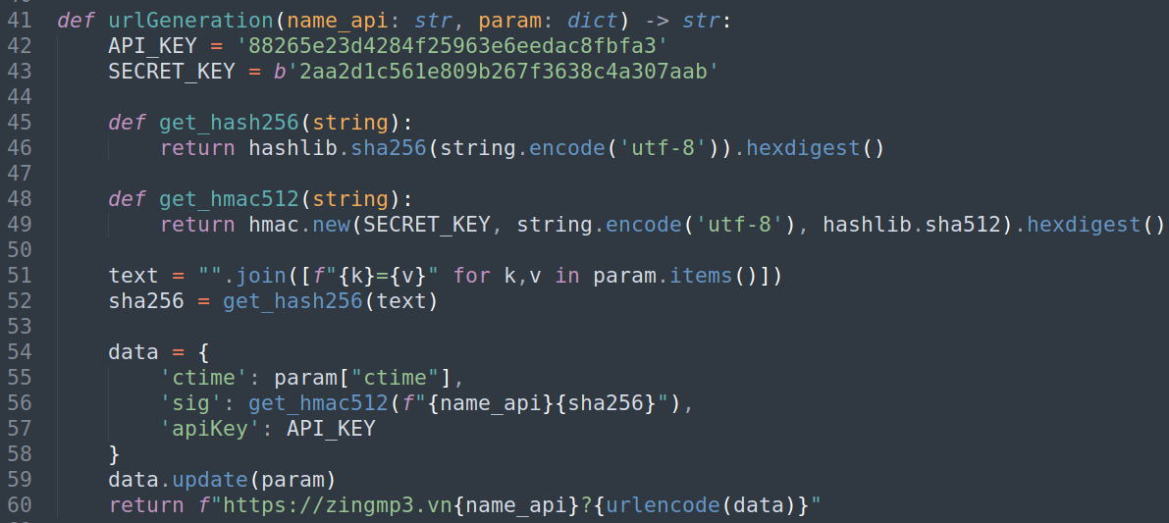

### Cookie

One more problem is a cookie. It has expired time and I had to identify after several times.

Luckily, website automatically resets a cookie when it expired.

I just make an invalid request containing an expired cookie and update my cookie by using “Set-Cookie” value in “Response Headers” of response data..

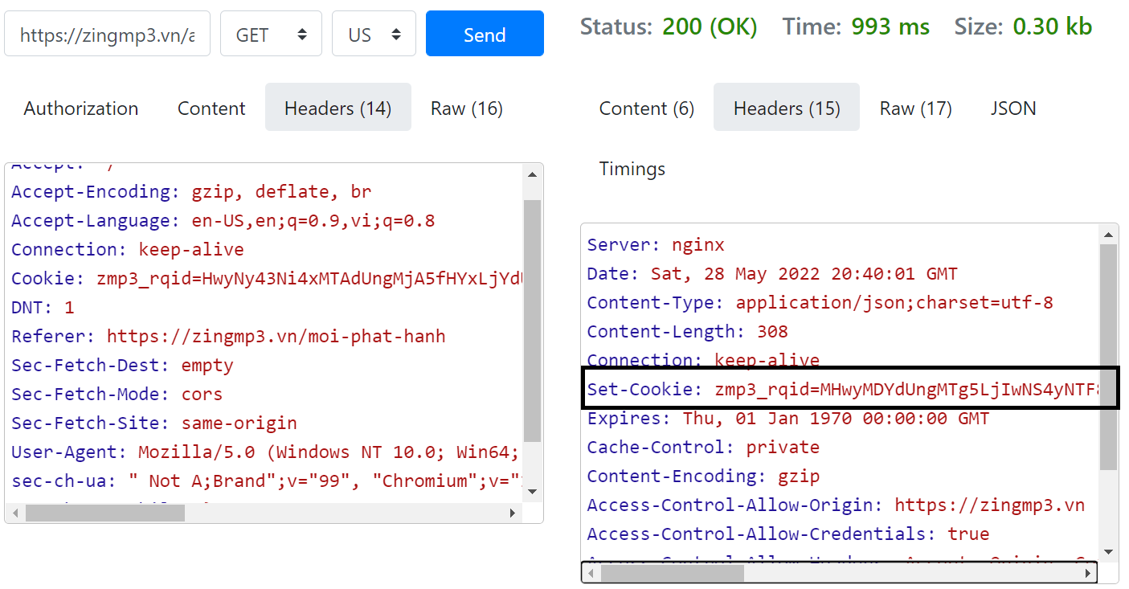

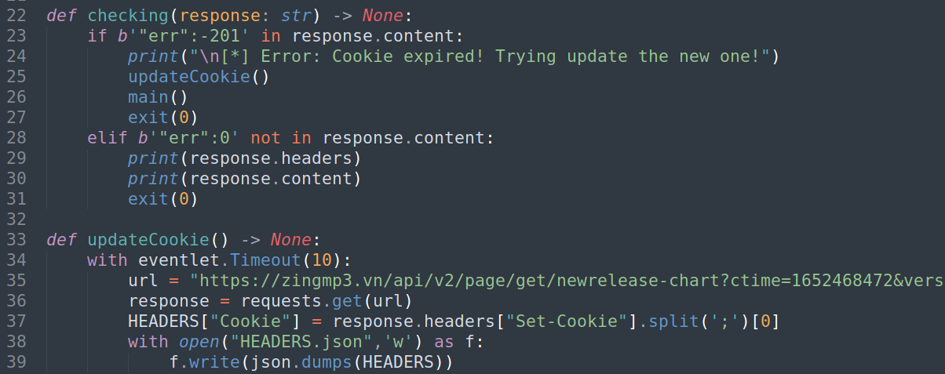

### List of songs

Request is good now, just catch the response data and find the “encodedID”. This is the representation code for each song.

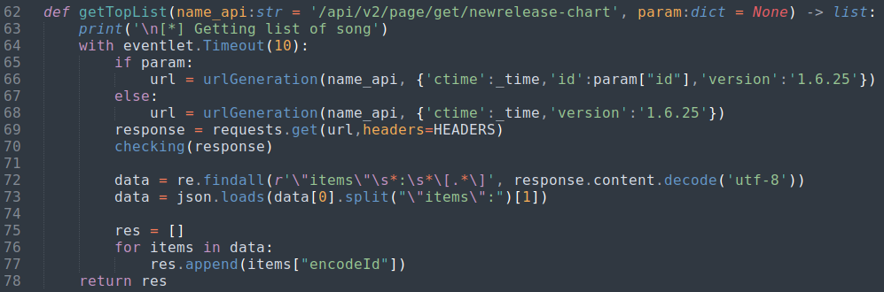

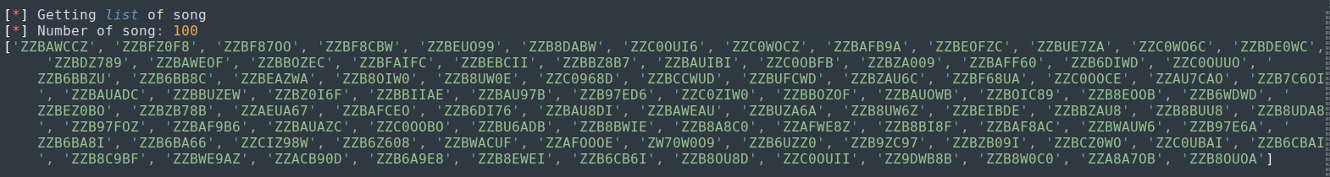

## Getting songs’ information

Everything gonna easy right now, based-on API link founded, I can use “encodeId” to request the json data.

In this task, parameter contain 3 elements, “ctime”, “id”, and “version” followed by an order.

https://zingmp3.vn/api/v2/page/get/song?id=ZZBUE7ZA&ctime=1652534700&version=1.6.25&sig=fa906944628776791050d19321ce2ade1227667cb1d032a77801e52461c62687fbcea9509e04c7f741f1c656ac0f562d2f8d7fc5554767c3051332e27f92234a&apiKey=88265e23d4284f25963e6eedac8fbfa3

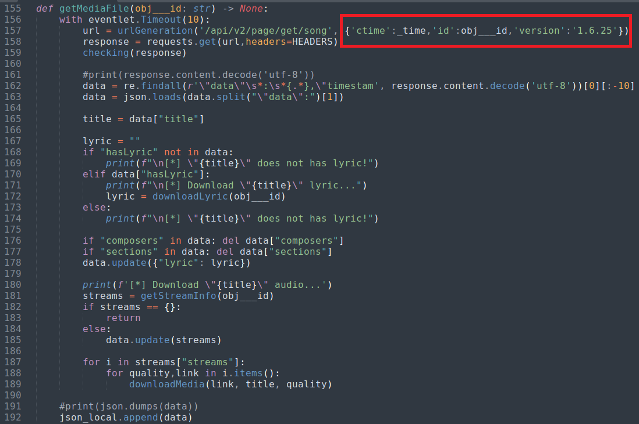

One more way, I can use regex to extract “encodeId” from song’s link.

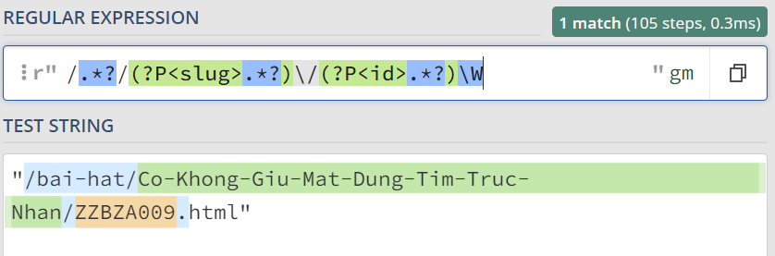

Receive response and get worth data into json list.

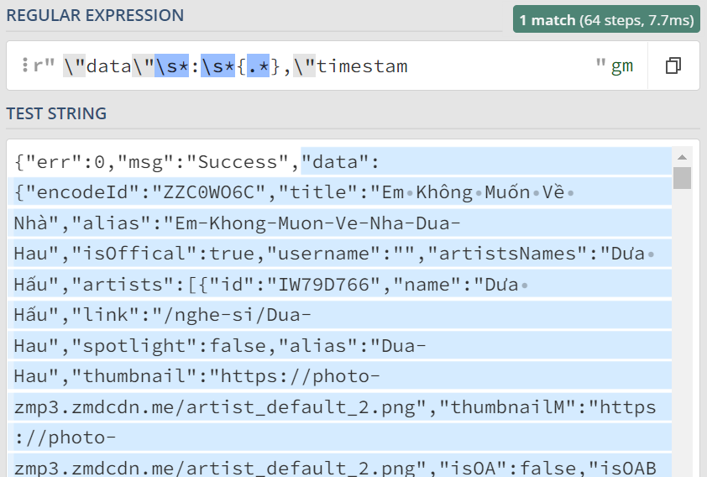

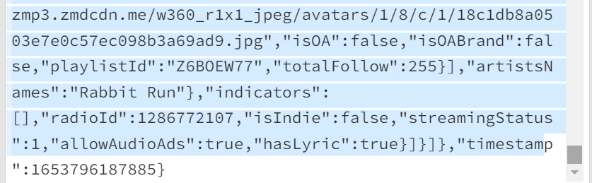

There is an argument named “hasLyric”, if the value is true, I can collect lyric’s song.

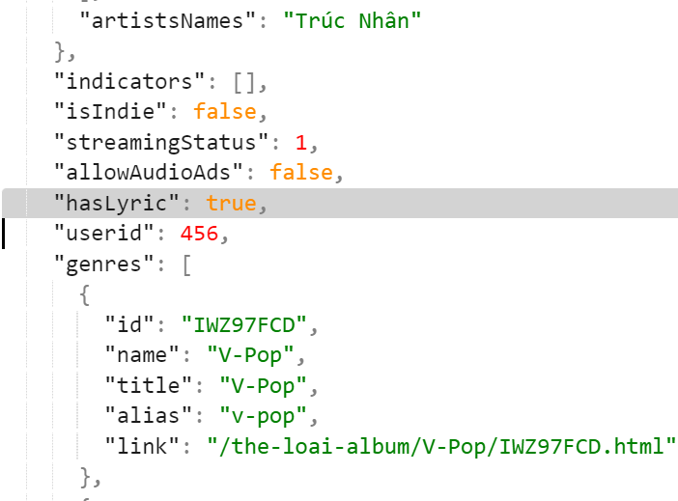

Then, download the audio file by linux commandline.

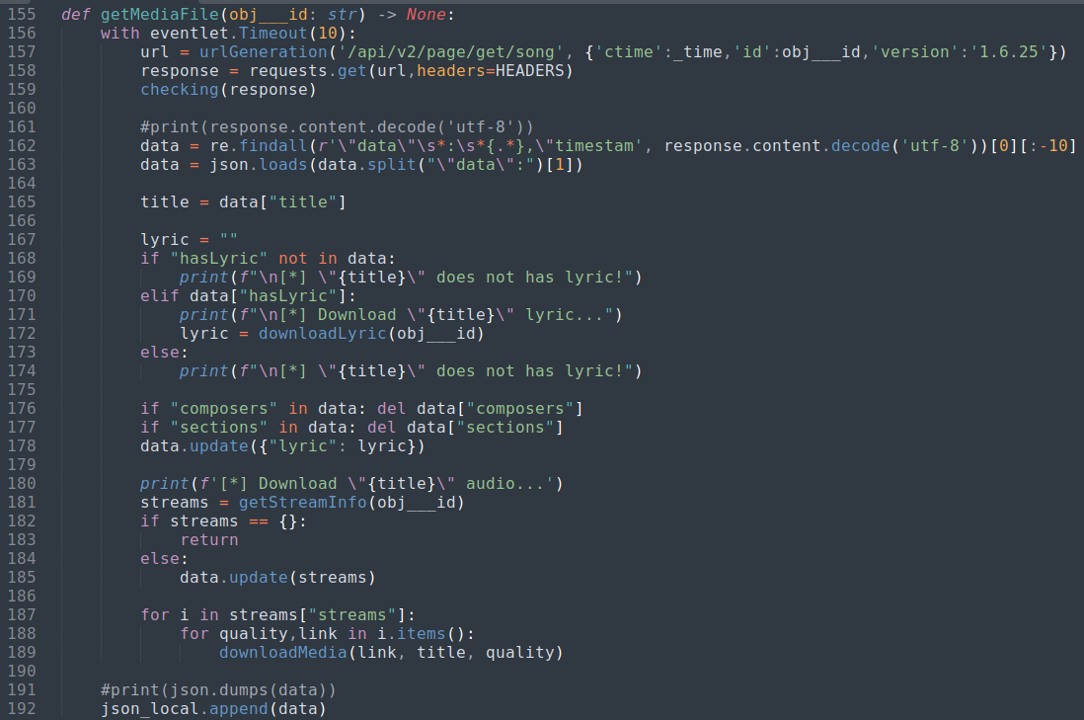

## Getting songs’ lyric

API link:

https://zingmp3.vn/api/v2/lyric/get/lyric?id=ZW6I979F&ctime=1652539551&version=1.6.25&sig=0c781dd12f369c3f062af7ee0fee8298c6c17edbb38ea87fac73cb989c239ccca94f4eb7fcee6e80468b014380ea08a74c94b3f2170deb4756d54ffb5a81f1bc&apiKey=88265e23d4284f25963e6eedac8fbfa3

Filter the response data:

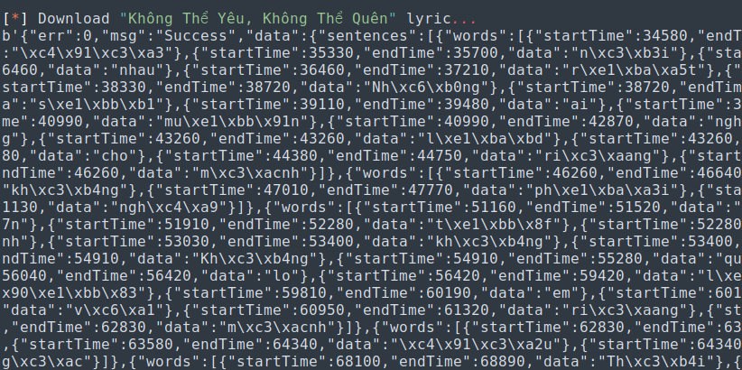

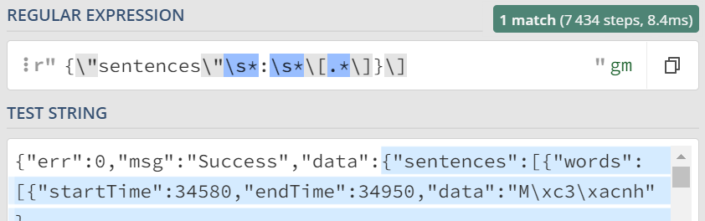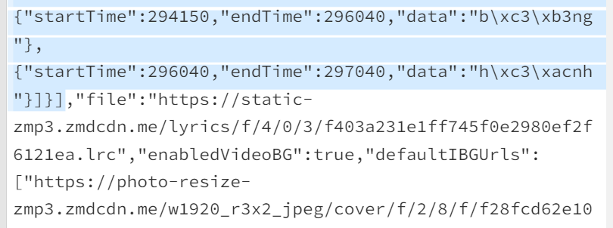

There are 3 types of saved lyric:

* First:

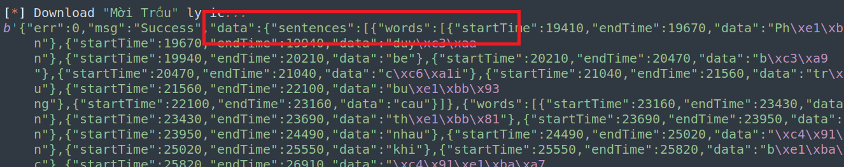

* Second:

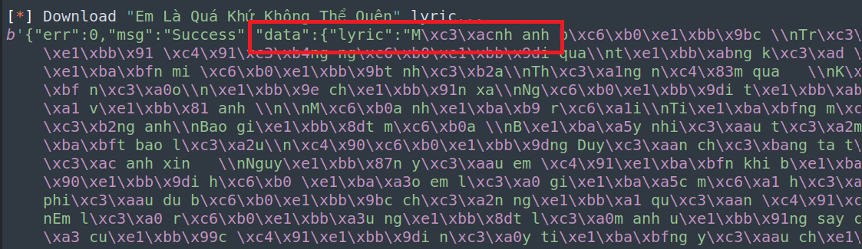

* Third:

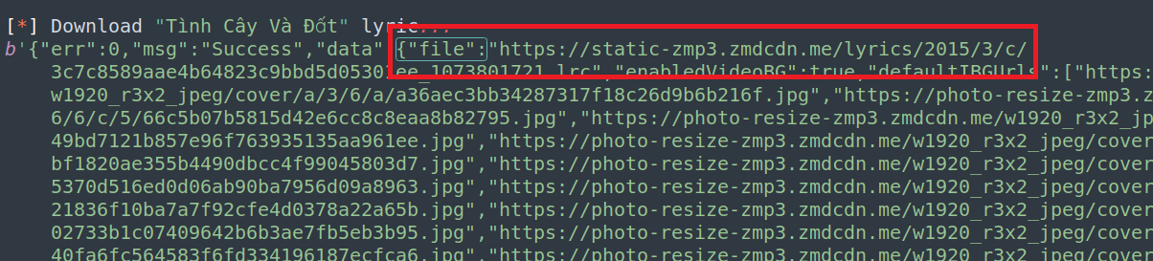

Get lyric function:

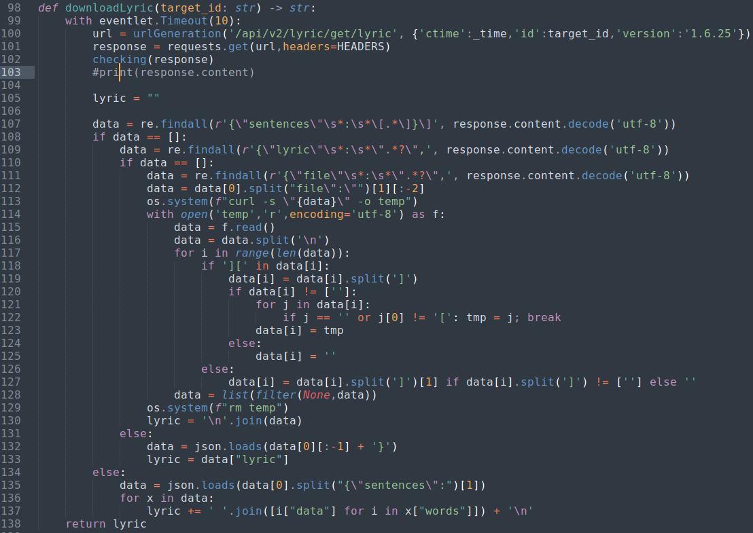

## Getting songs’ audio

This function, “getStreamInfo” will get all streams of one song, choose the one available to download.

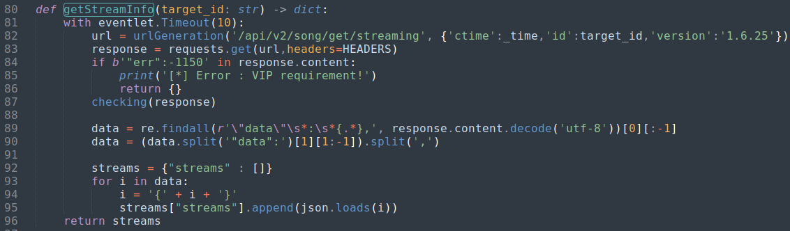

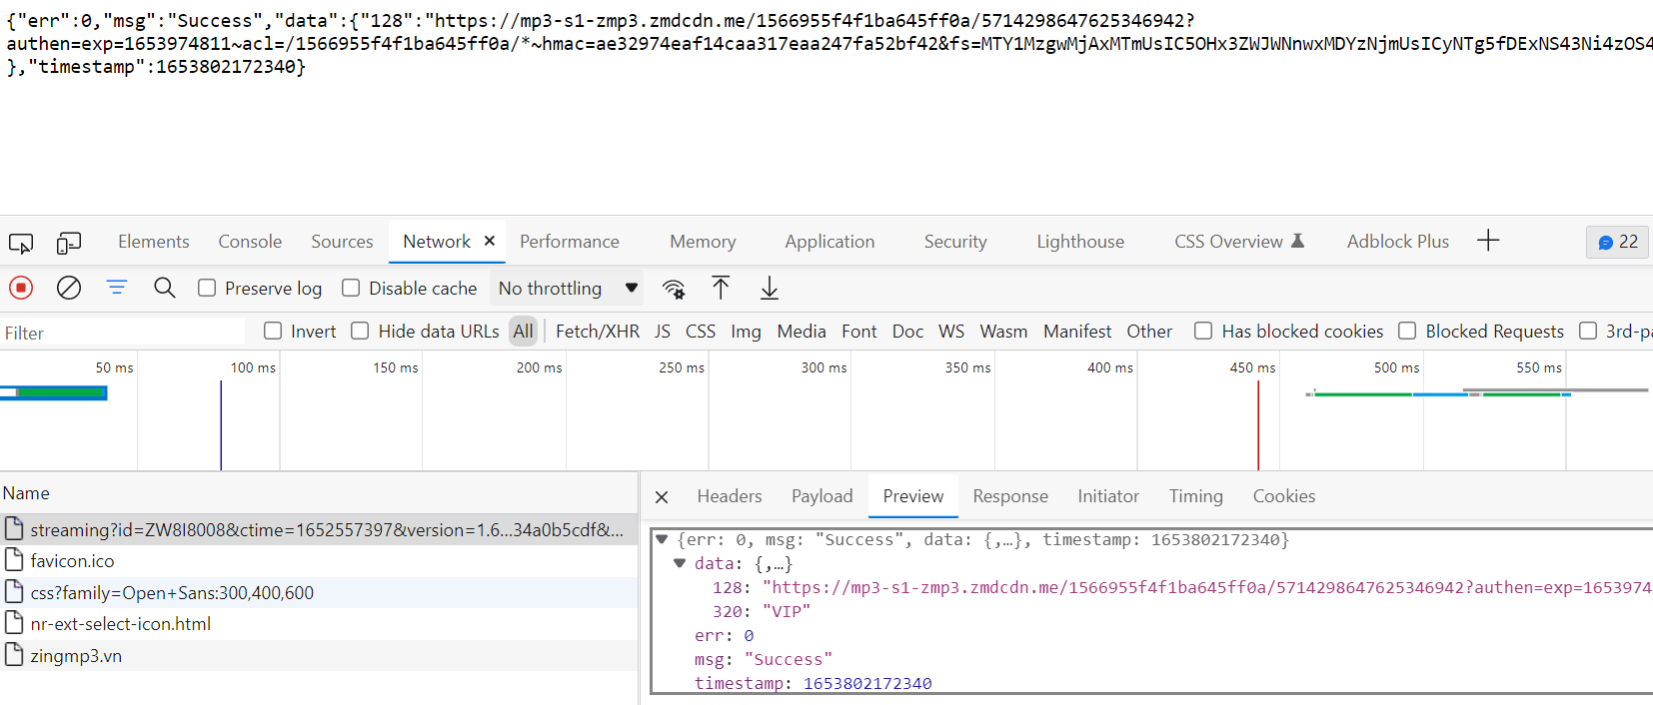

“downloadMedia” use linux commandline to download and save the audio file as {title}_{quality} in DOWNLOAD folder.

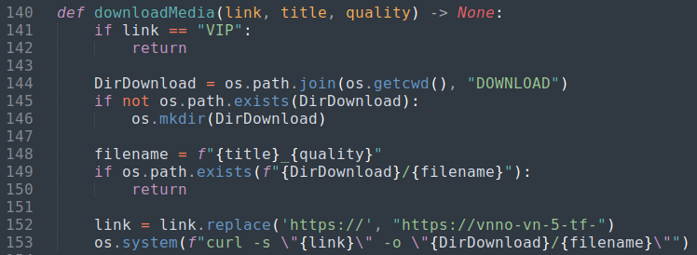

## Main function

Finally, combine all to one json element and add them to json object.

Elsewhere, check if “encodeId” for existing songs.

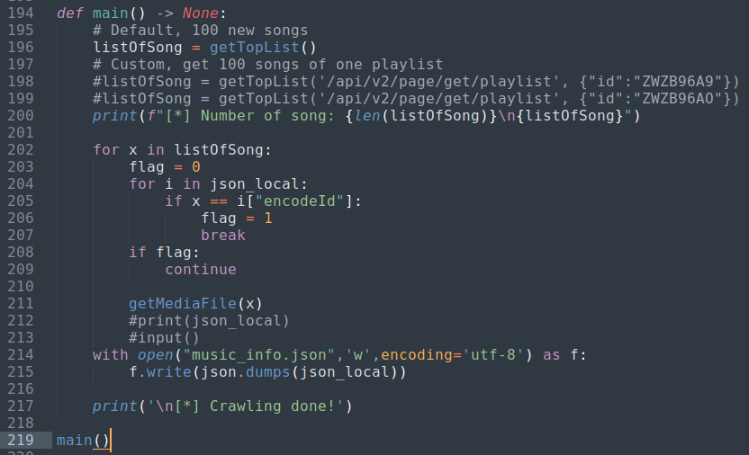

Otherwise, download the list of top 100 songs by getting a playlist id.

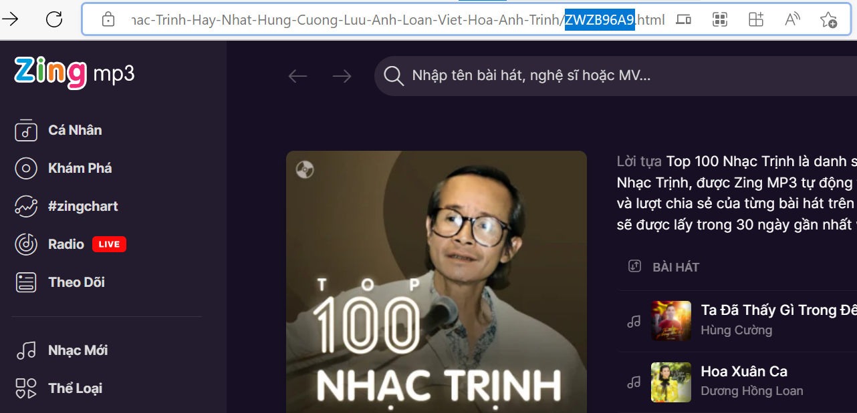

# Music Player

Simply make html and js webpages, list information of song and response audio file.

## webserver.py

Processing for each webpage.

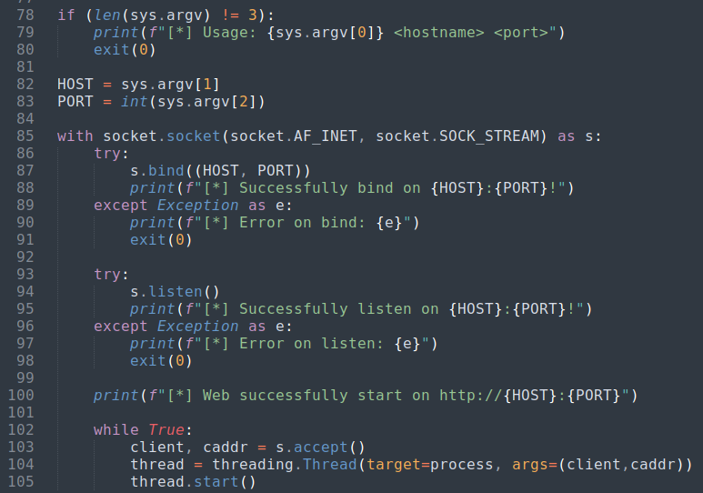

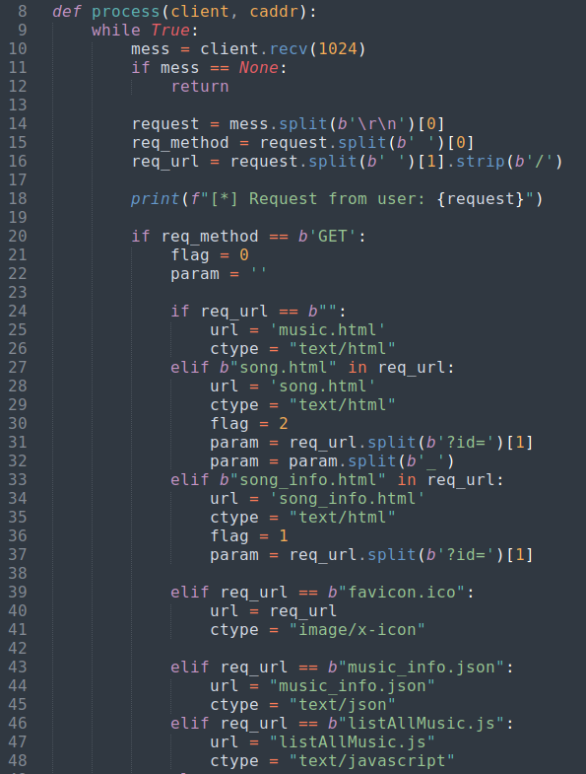

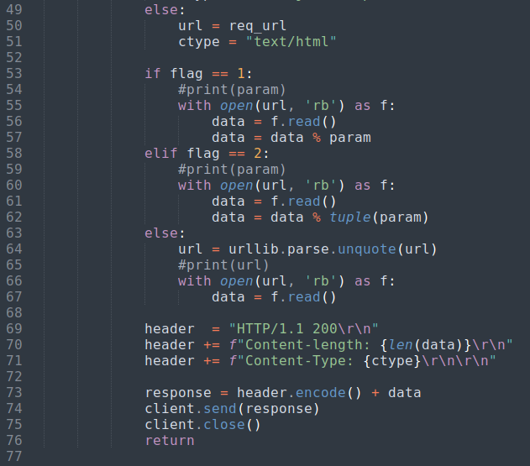

## music.html

Listing all the songs.

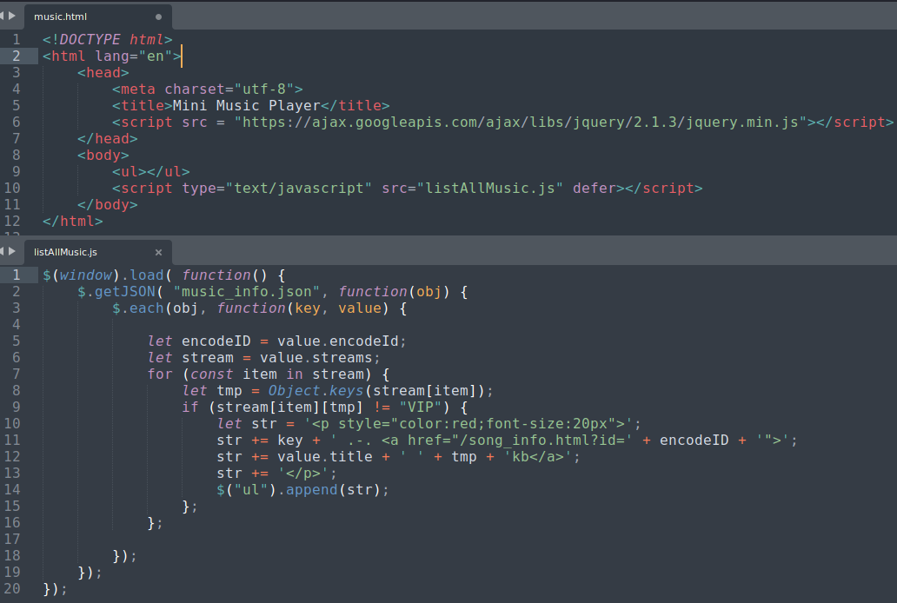

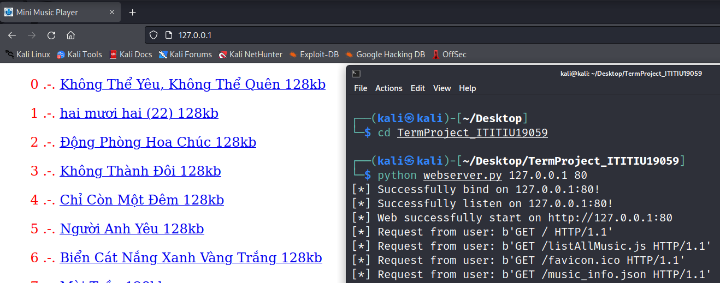

## song_info.html

Getting main information of song, click spotify button for play.

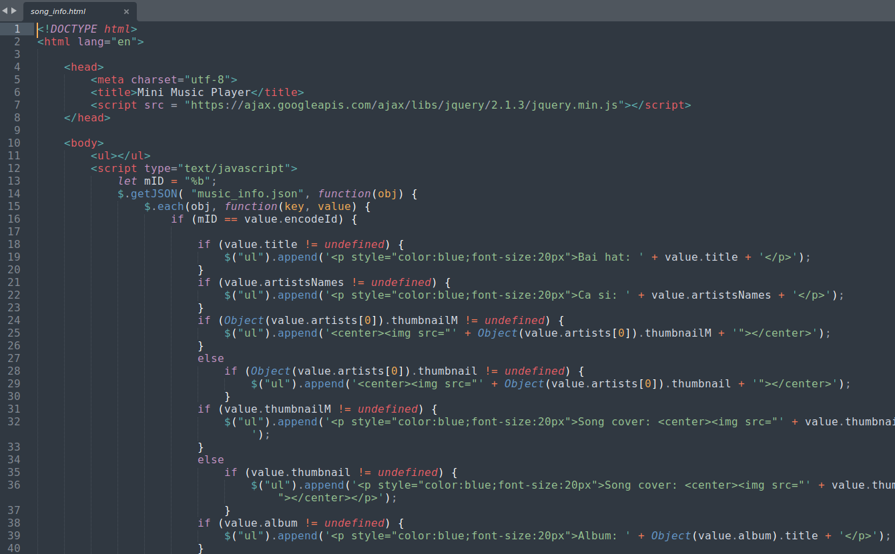

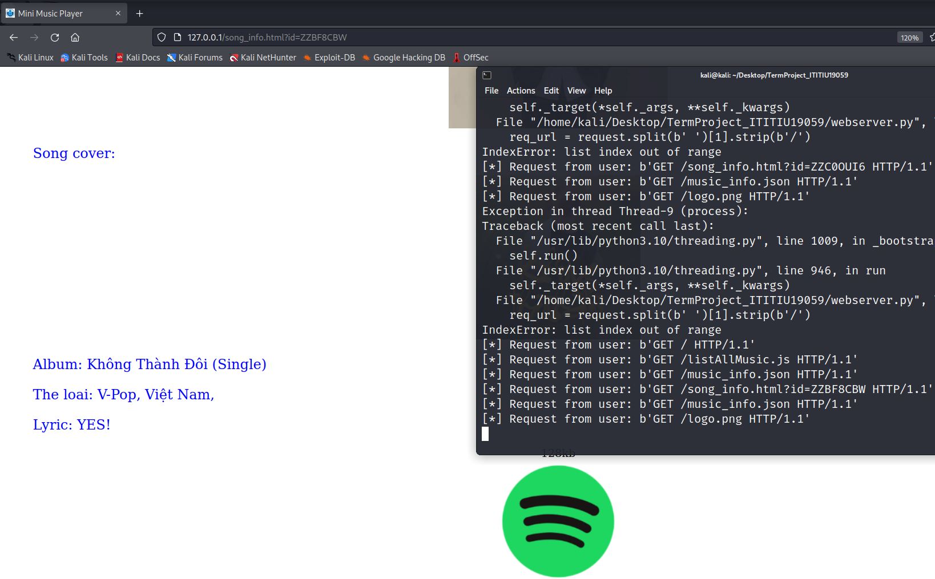

## song.html

Show play place and lyric.

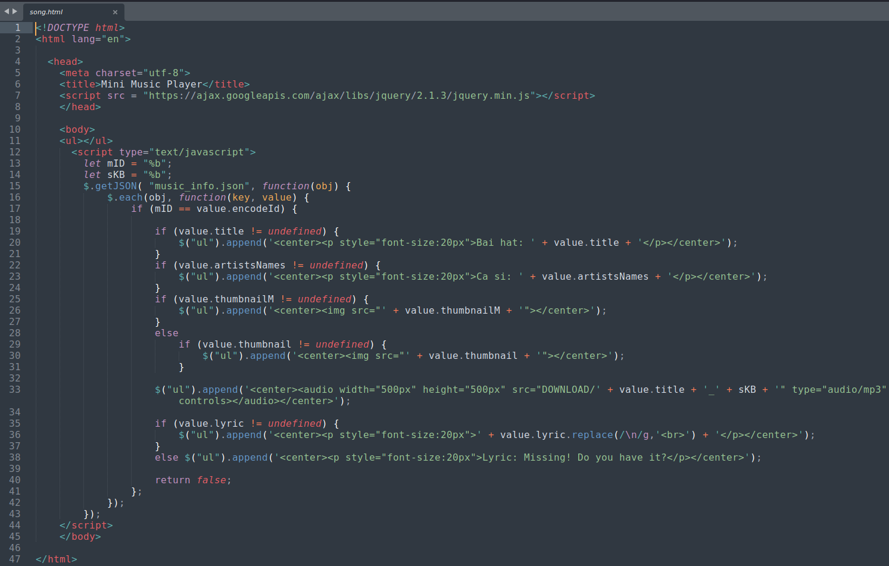

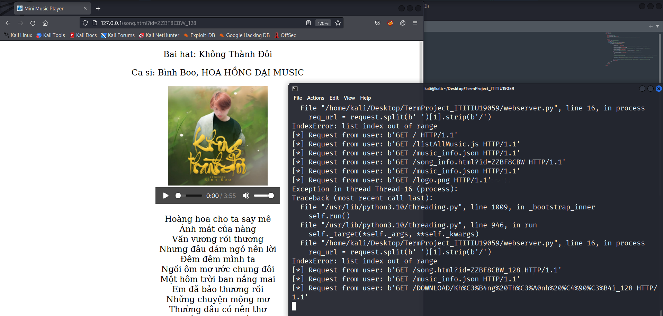

# Usage

* musiccrawler.py
  + Simply run it with command

python3 musiccrawler.py

* + If you want to collect a playlist, following part 2.5
* webserver.py
  + This script receive 2 arguments, <ip> and <port>.

python3 webserver.py 127.0.0.1 80

# Conclusion

This project gives me more experience and a sense of working with web applications, changing my mind that web is the simplest part of programming.

Handling json data, know how to work and choose between multiple types of custom data or information.

# Referrer

zingmp3 crawler on previous zingmp3’s version: https://github.com/hatienl0i261299/Zingmp3